DBMS Assignment

Q1) Create table EMPLOYEE with the following details.

* create database EMPLOYEE;
* use EMPLOYEE;
* create table EMPLOYEE(EMPLOYEE_ID float(6) primary key, LAST_NAME varchar(25) not null, JOB_ID varchar(10) not null, SALARY float(8,2), COMM_PCT float(4,2), MGR_ID float(6), DEPARTMENT_ID float(4));
* desc EMPLOYEE;

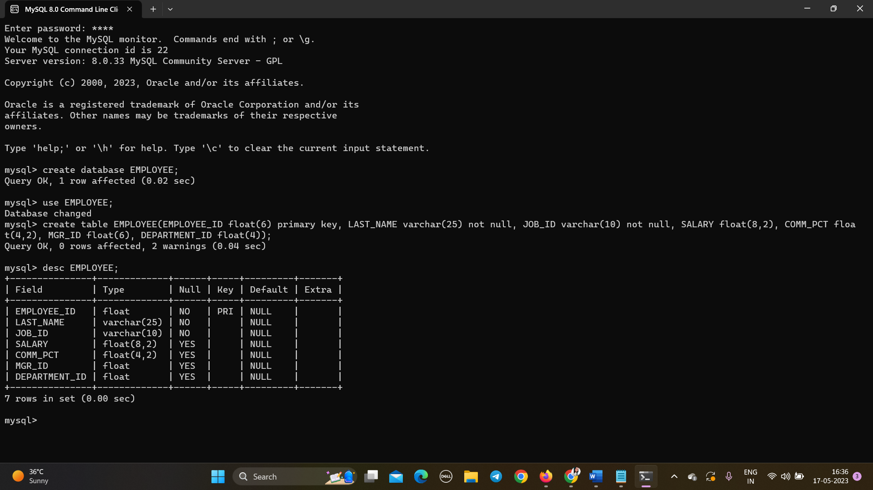

Q2. Insert the following data into EMPLOYEE table.

* insert into EMPLOYEE values(198,'Connell','SH_CLEARK',2600,2.5,124,50) ,(199,'Grant','SH_CLEARK',2600,2.2,124,50),(200,'Whalen','AD_ASST',4400,1.3,101,10),(201,'Hartstein','IT_PROG',6000,null,100,20),(202,'Fay','AC_MGR',6500,null,210,20),(203,'Mavris','AD_VP',7500,null,101,40),(204,'Baer','AD_PRES',3500,1.5,101,90),(205,'Higgins','AC_MGR',2300,null,101,60),(206,'Gitz','IT_PROG',5000,null,13,60),(100,'King','AD_ASST',8956,0.3,108,100),(101,'Kochar','SH_CLEARK',3400,1.3,118,30);

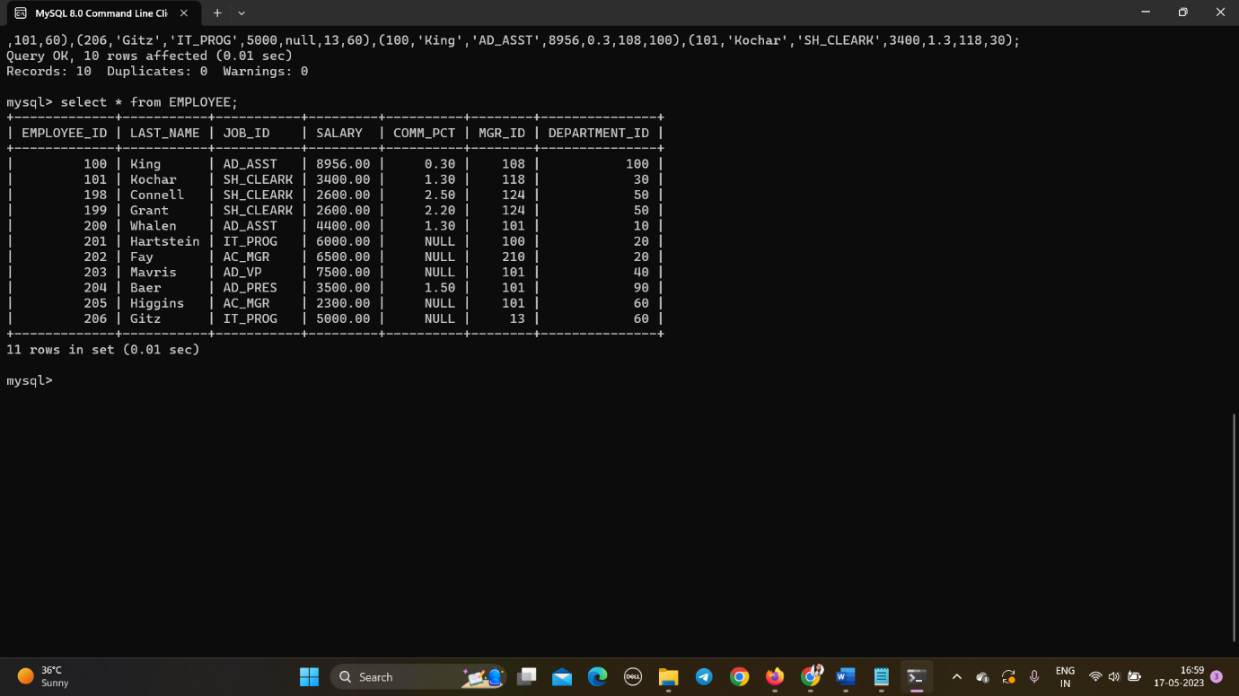

Q3. Display last_name, job_id, employee_id for each employee with employee_id  
appearing first.

* select EMPLOYEE_ID,LAST_NAME,JOB_ID from EMPLOYEE;
* 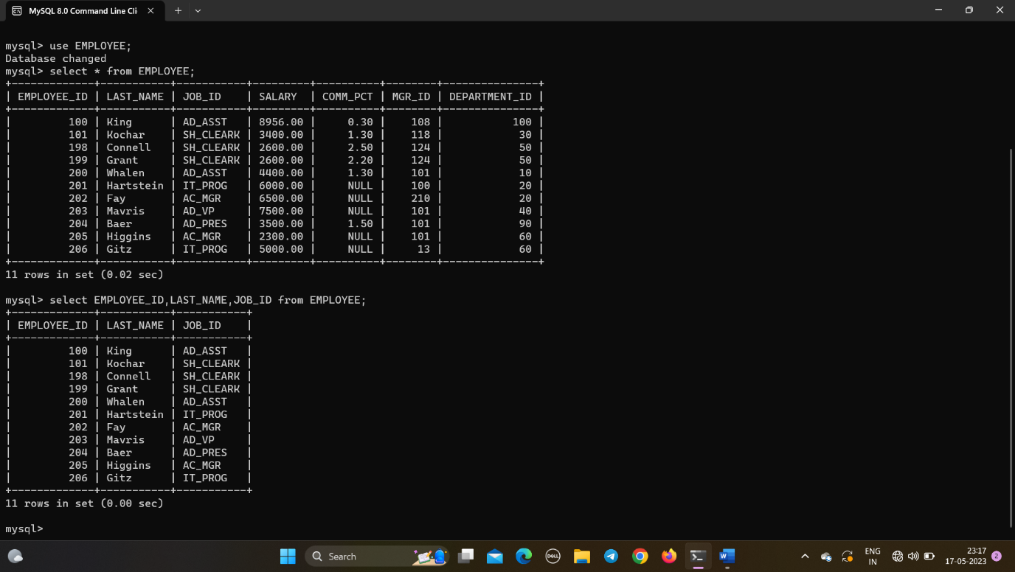

Q4. Display the details of all employees of department 60.

* select * from EMPLOYEE where DEPARTMENT_ID in(60);
* 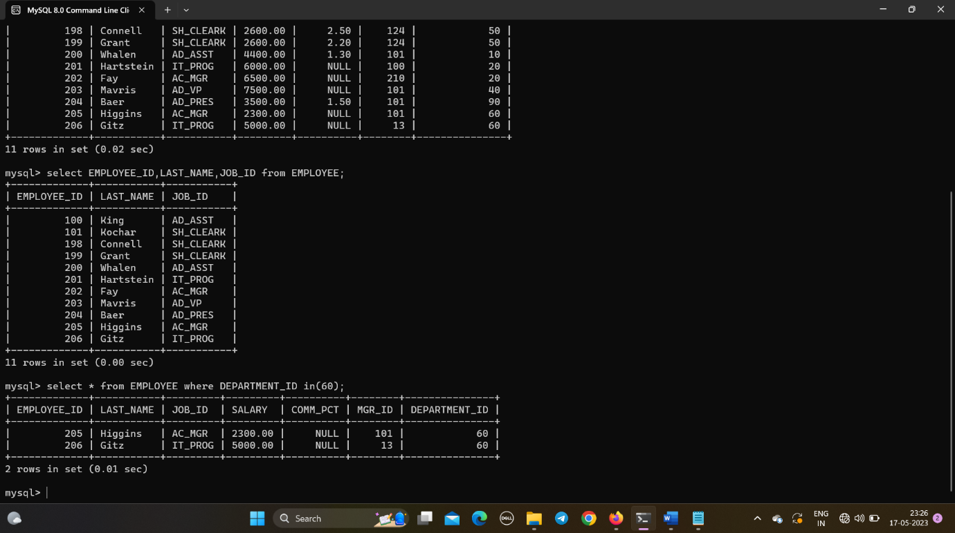

Q5. Display the employee details of the employee who’s last_name is King.

* select * from EMPLOYEE where LAST_NAME like 'King';
* 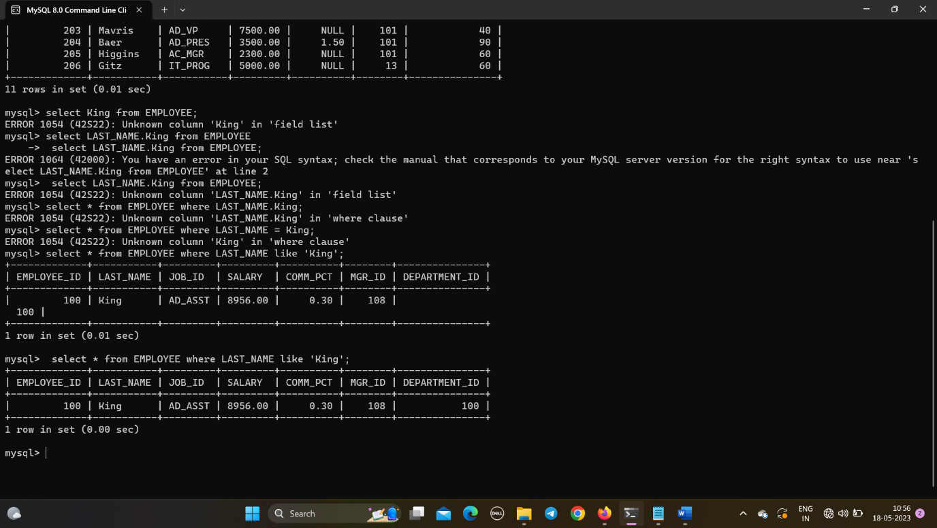

Q6. Display unique job_id from EMPLOYEE table. Give alias name to the column as  
JOB_TITLE.

* select distinct JOB_ID from EMPLOYEE;
* 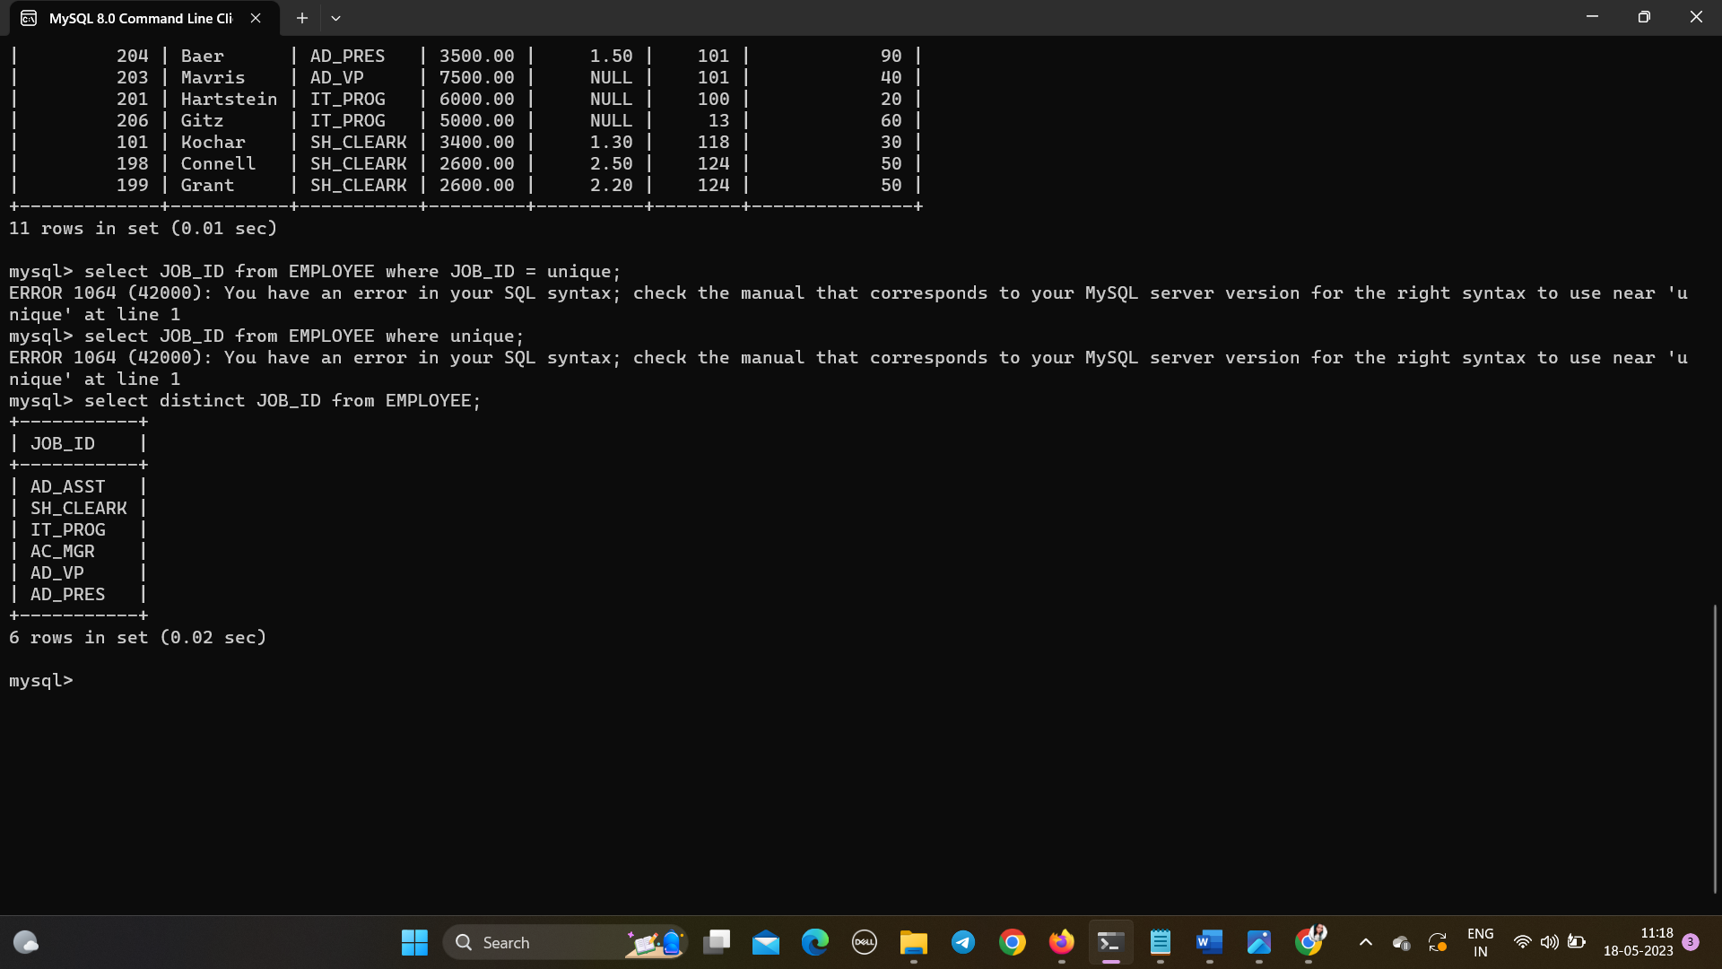
* select JOB_ID as 'JOB_TITLE' from EMPLOYEE;
* 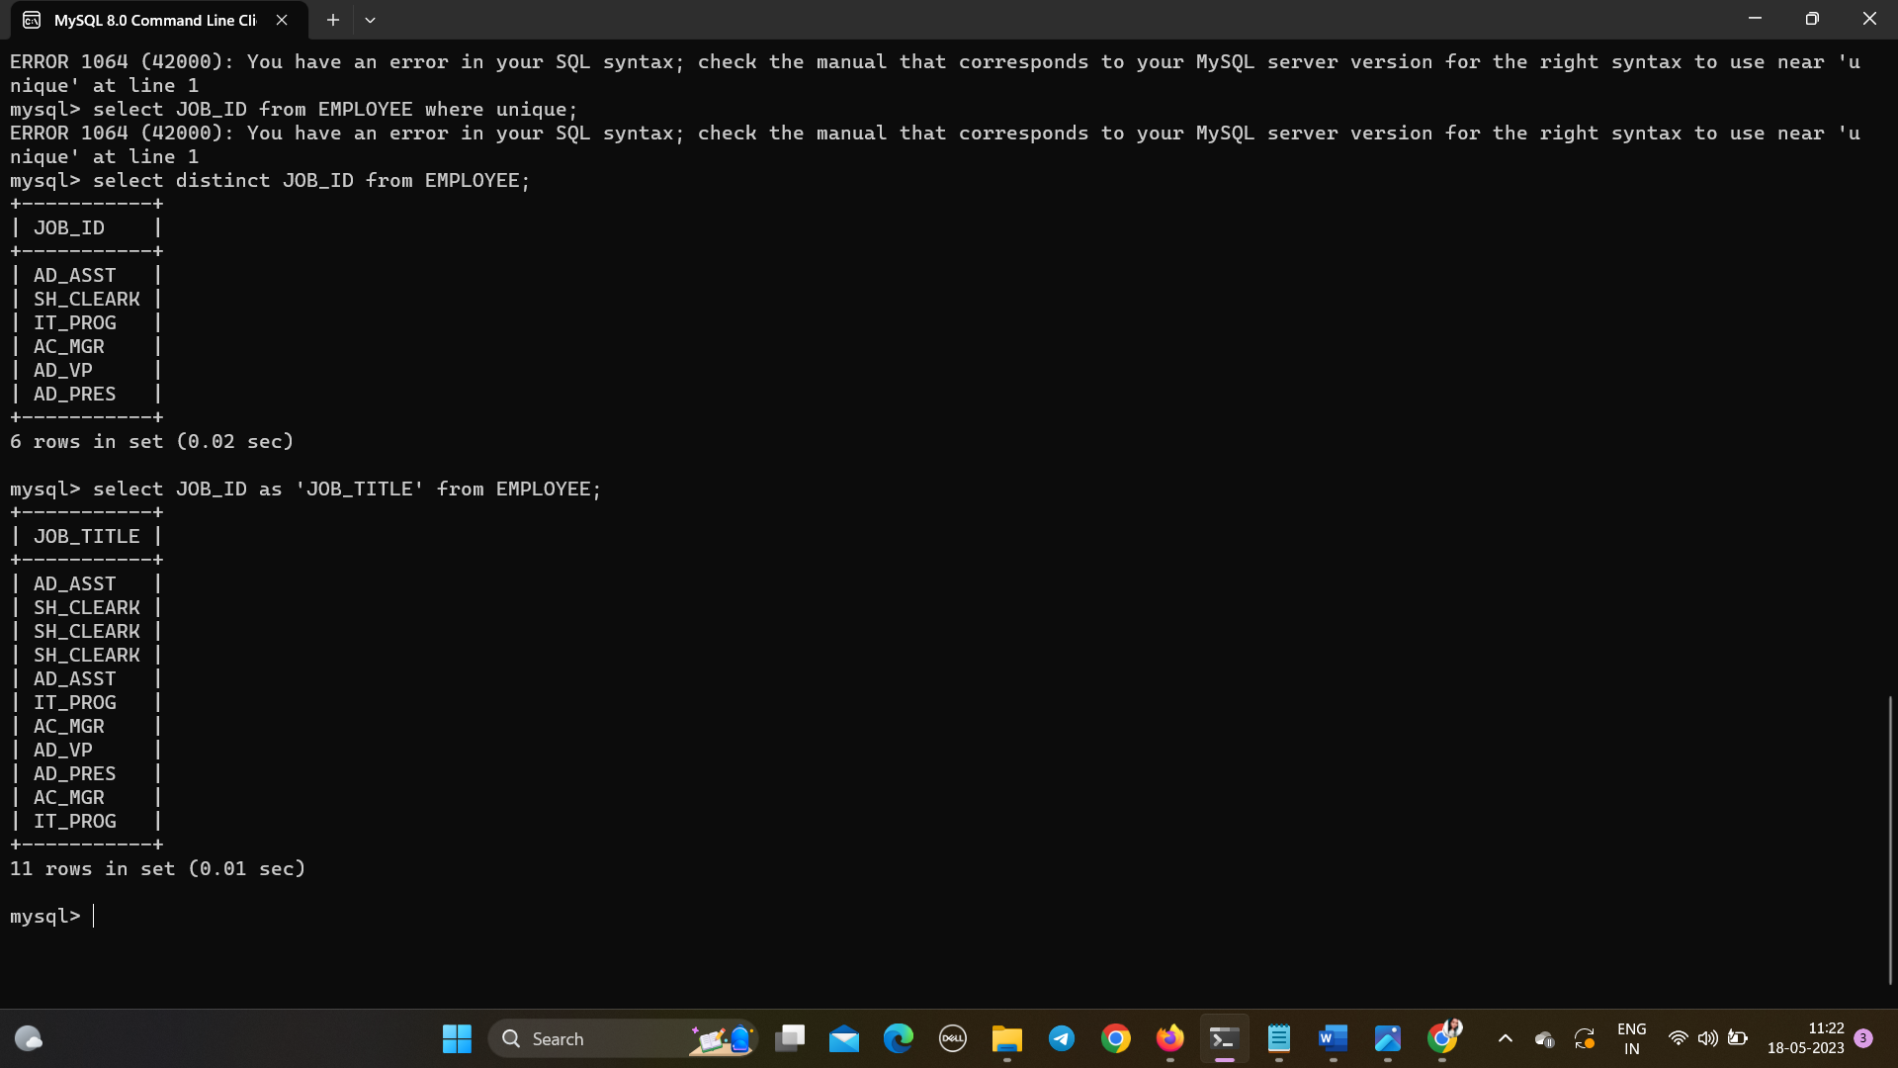

Q 7. Display last_name, salary and salary increase of Rs300. Give the new column name  
as ‘Increased Salary’.

* select LAST_NAME,SALARY,(SALARY+300)as'Increased_Salary' from EMPLOYEE;
* 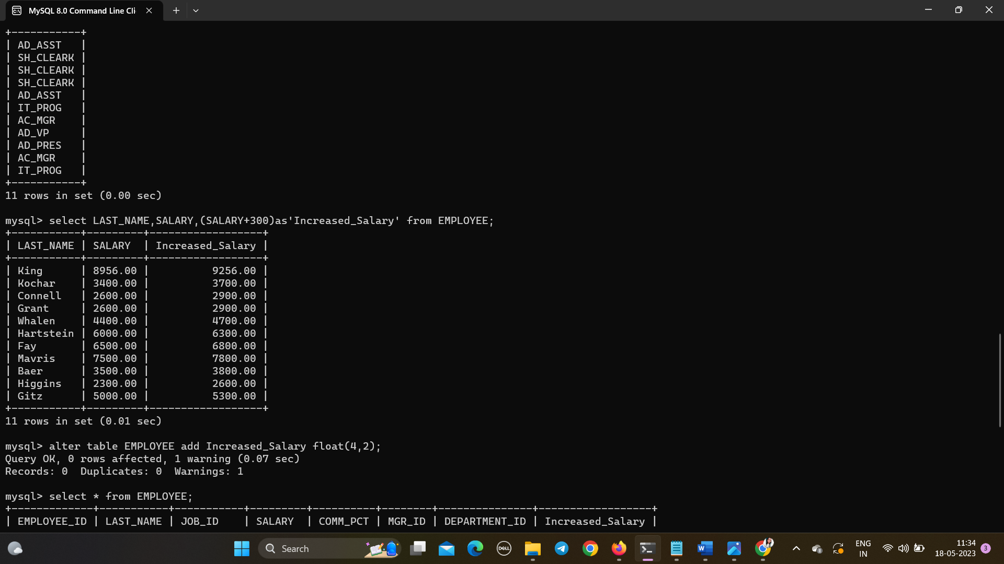

Q8. Display last_name, salary and annual compensation of all employees, plus a  
onetime bonus of Rs 100. Give an alias name to the column displaying annual  
compensation.

* select LAST_NAME,SALARY,(SALARY*12)+100 as annual_compensation from EMPLOYEE;
* 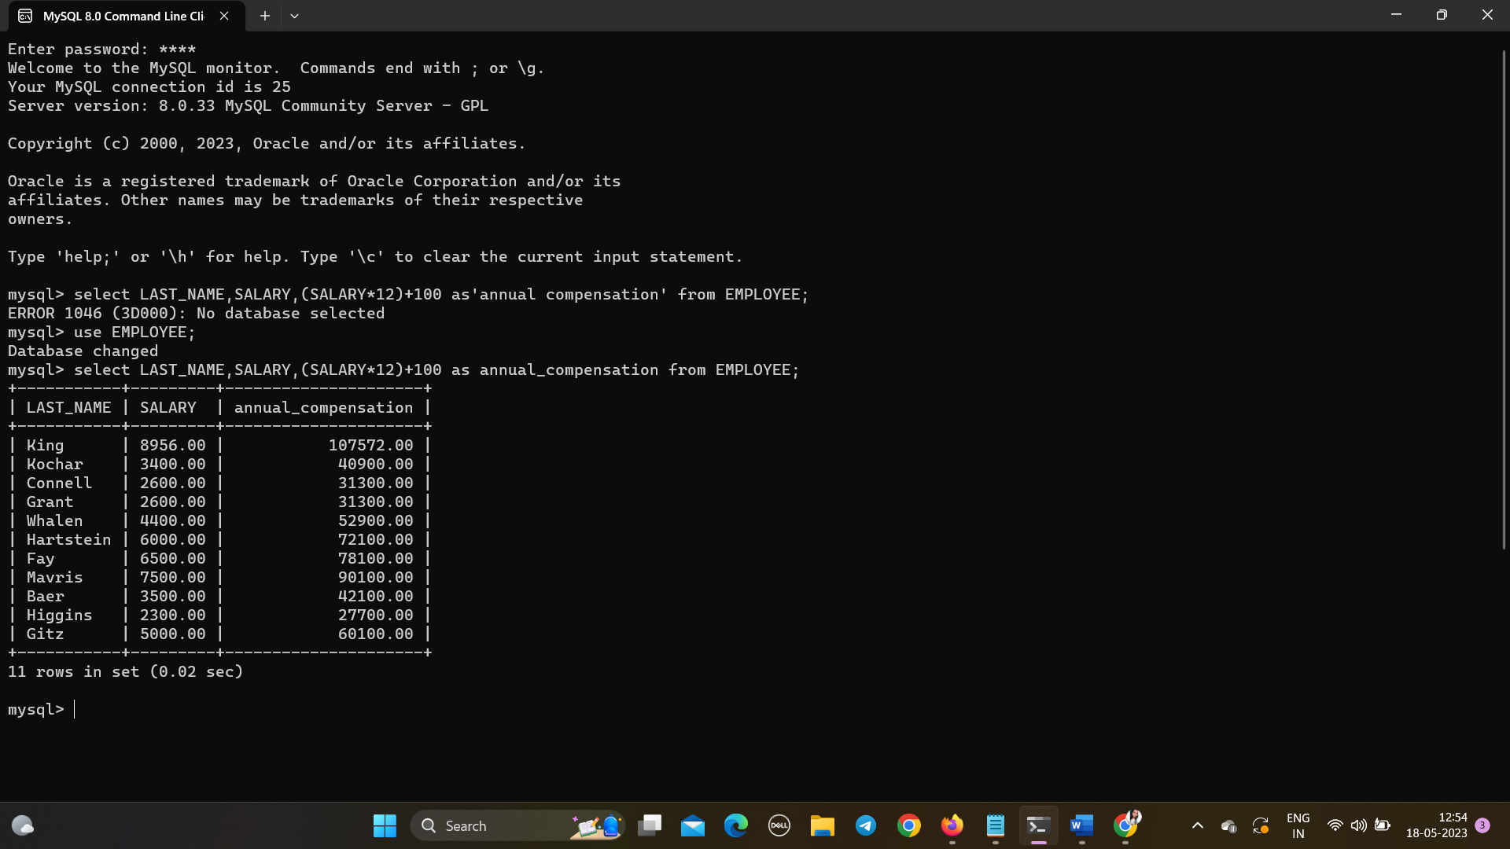

Q9. Display the details of those employees who get commission.

* select * from EMPLOYEE where COMM_PCT>0;
* 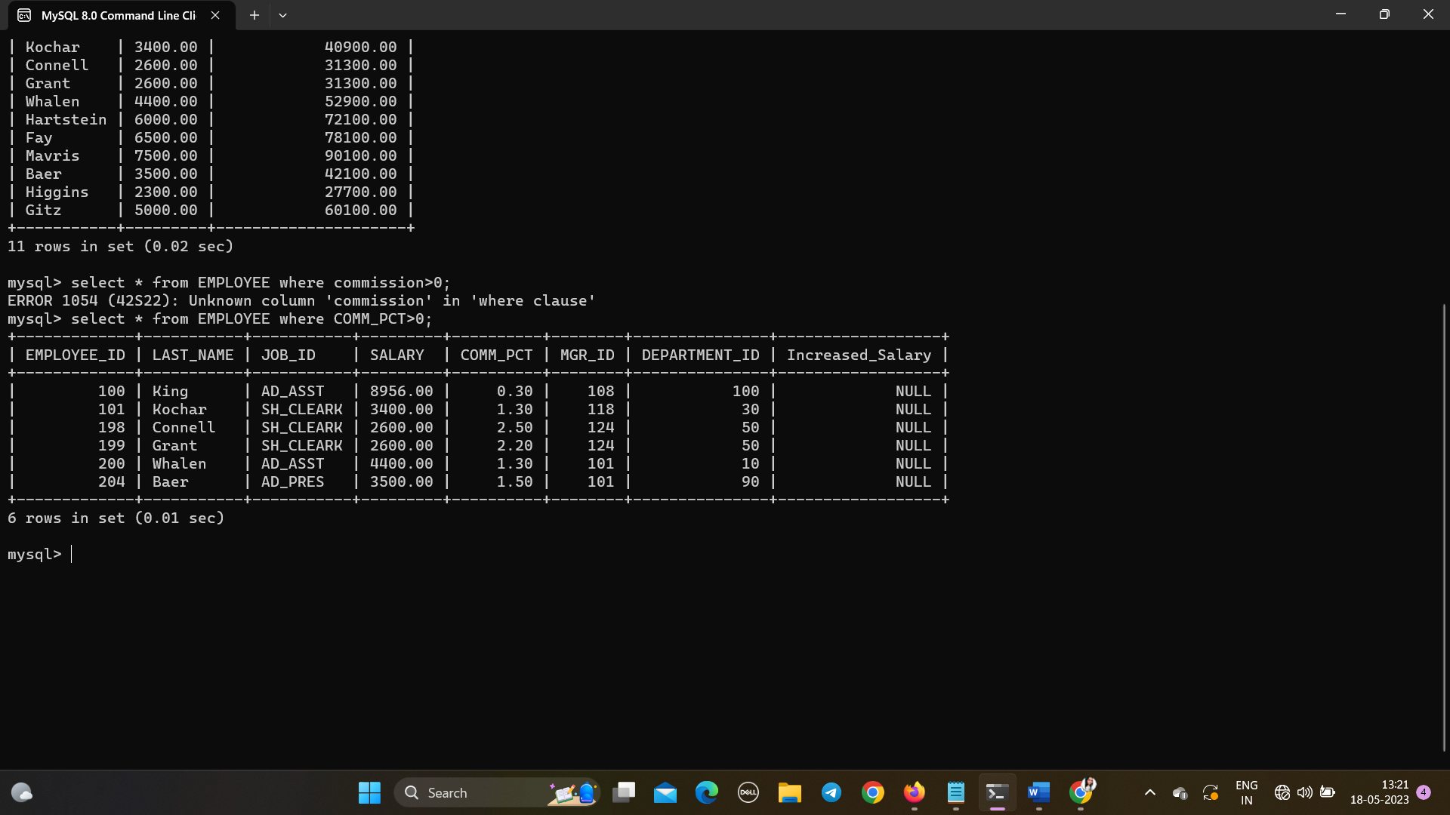

Q10. Display the details of those employees who do not get commission.

* 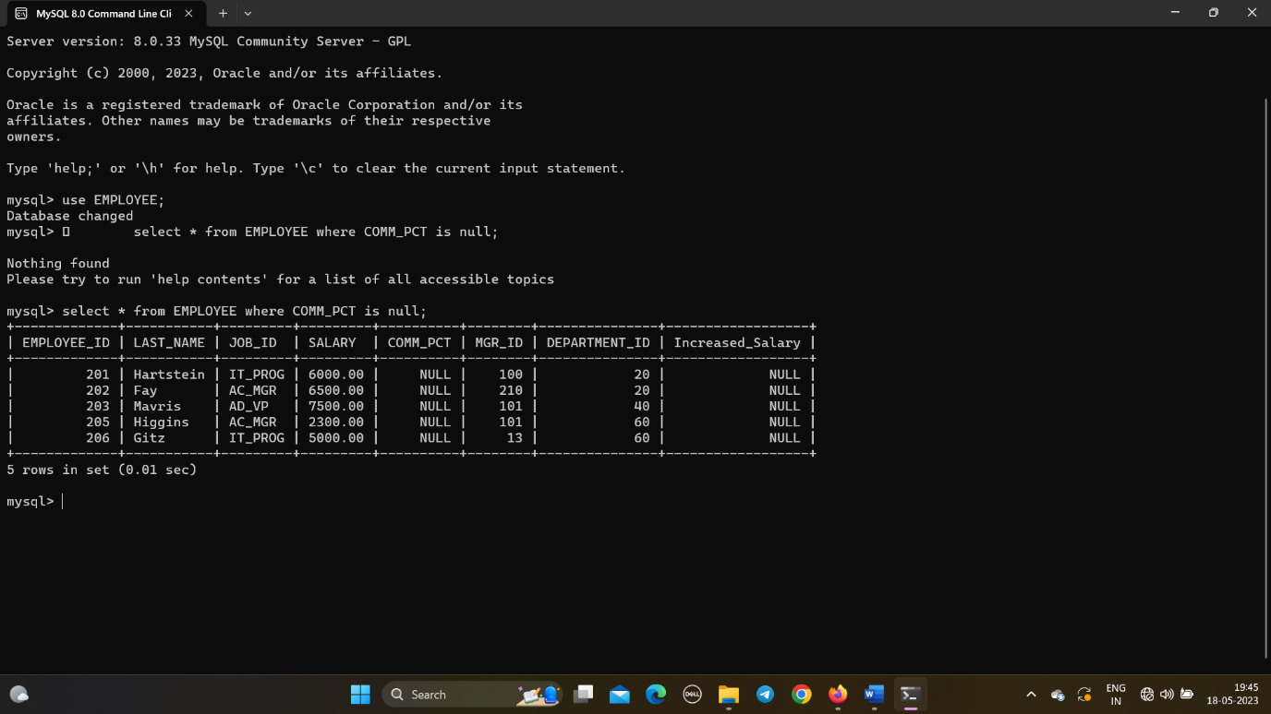select * from EMPLOYEE where COMM_PCT is null;

Q11. Display the Employee_id, Department_id and Salary all employees whose salary is  
greater than 5000.

* select EMPLOYEE_ID,DEPARTMENT_ID,SALARY from EMPLOYEE where SALARY > 5000;
* 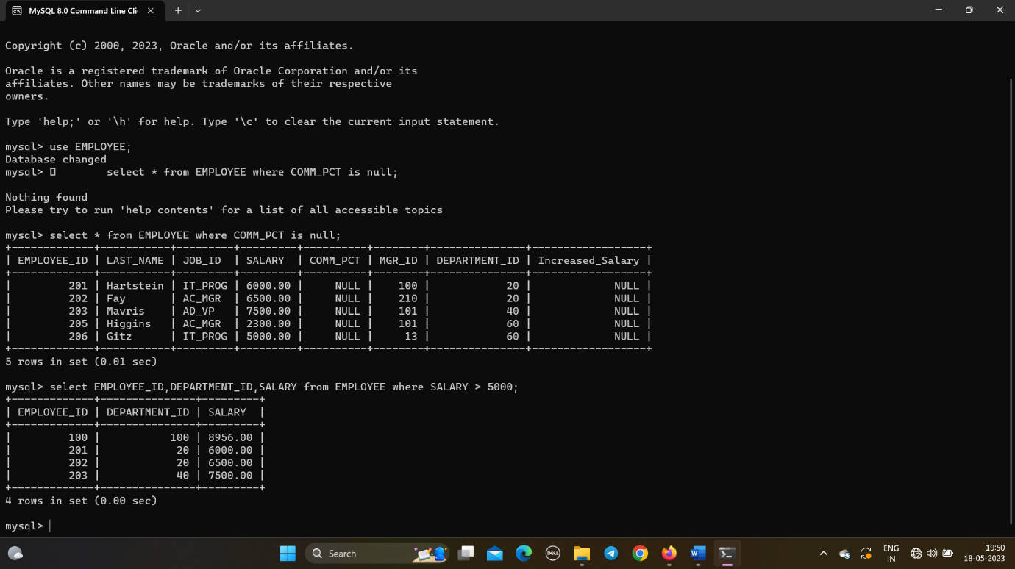

Q 12. Display the Last_Name and Salary of all employees whose salary is between 4000  
and 7000.

* select LAST_NAME,SALARY from EMPLOYEE where SALARY between 4000 and 7000;
* 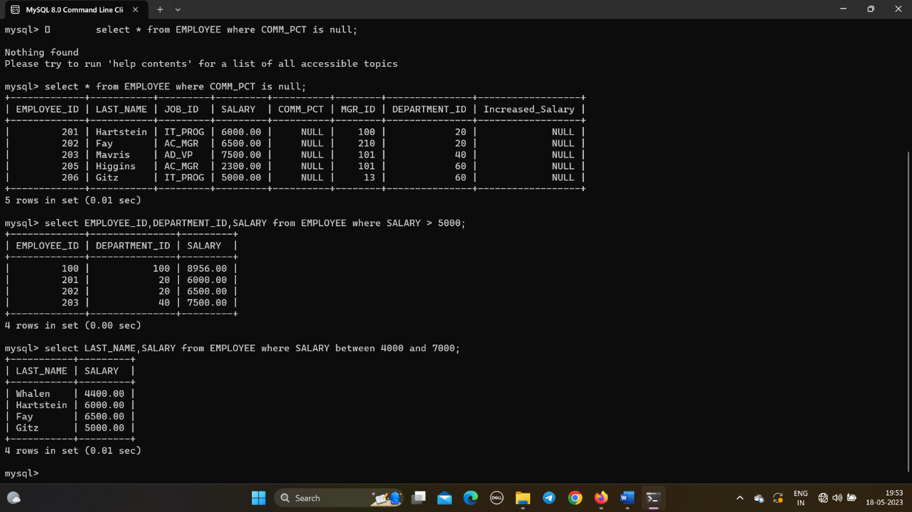

Q13. Display the details of all employees whose salary is either 6000 or 6500 or 7000.

* select * from EMPLOYEE where SALARY in (6000,6500,7000);
* 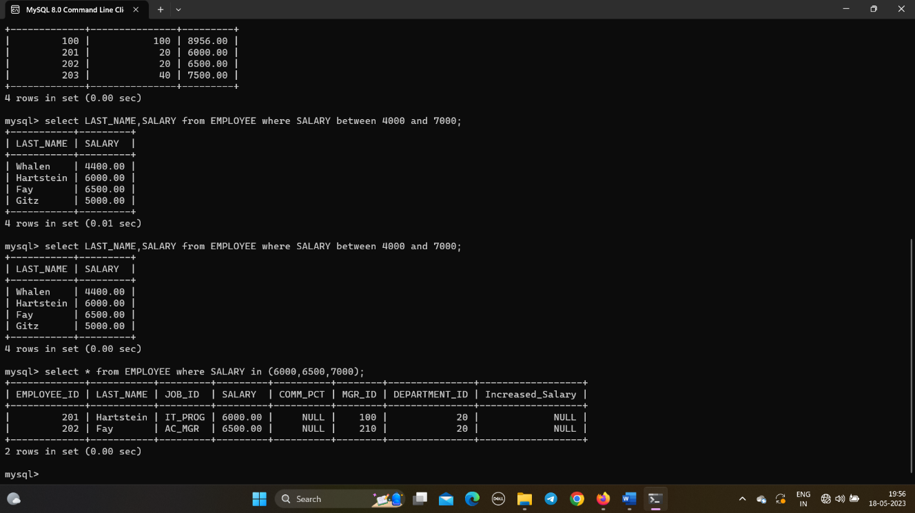

Q14. Display the details of all those employees who work either in department 10 or 20  
or 30 or 50.

* select * from EMPLOYEE where DEPARTMENT_ID in (10,20,30,50);
* 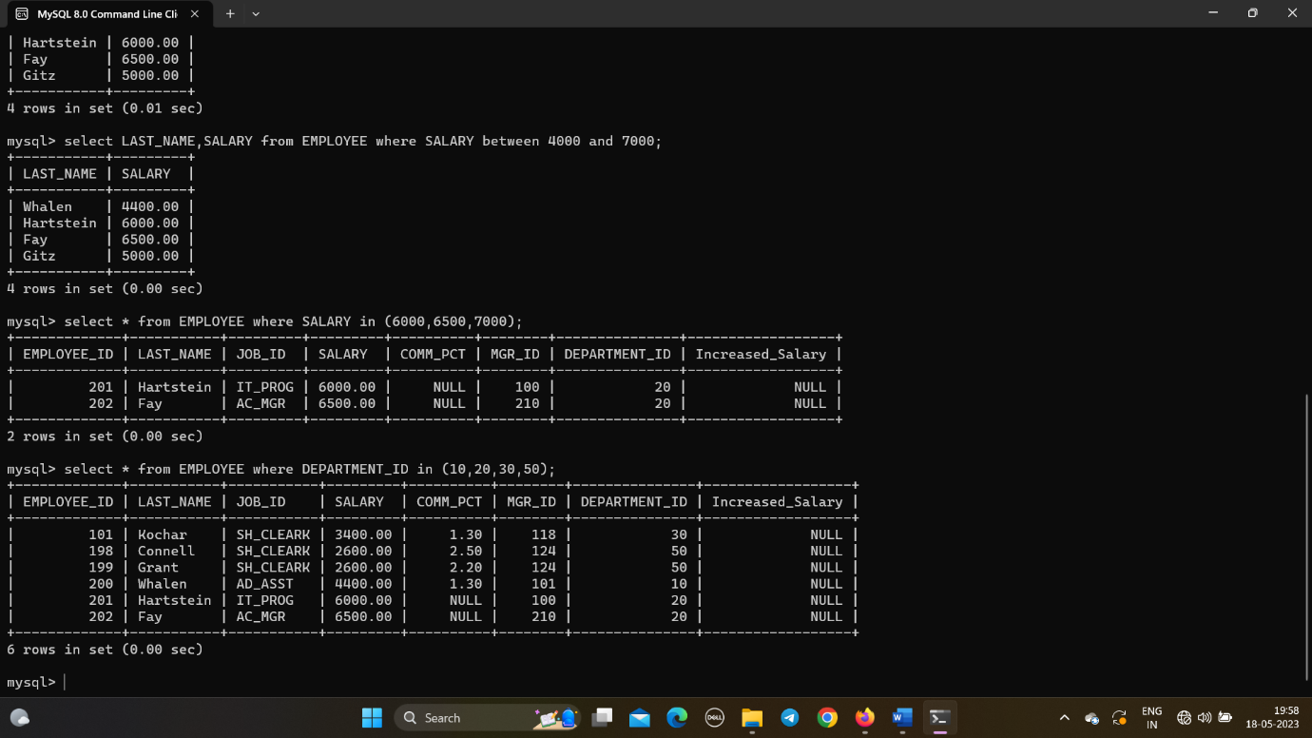

Q15. Display the details of all employees whose salary is not equal to 5000.

* select * from EMPLOYEE where SALARY != 5000;
* 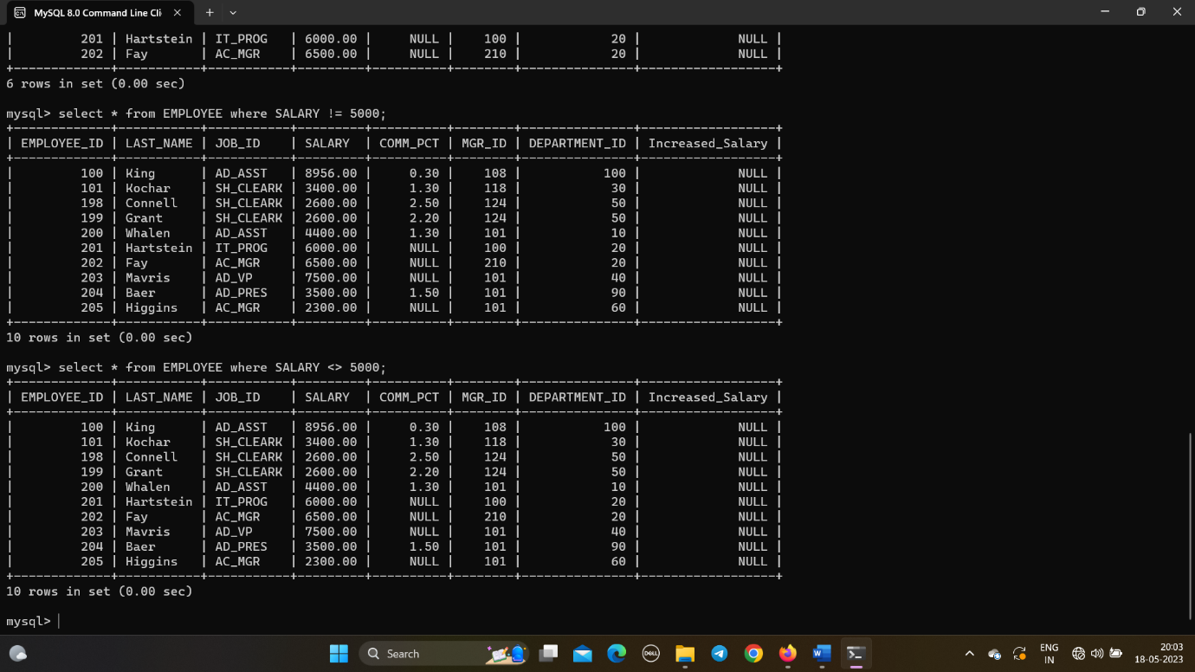

Q16. Display the details of all the CLERKS working in the organization.

* select * from EMPLOYEE where JOB_ID = 'SH_CLEARK';
* 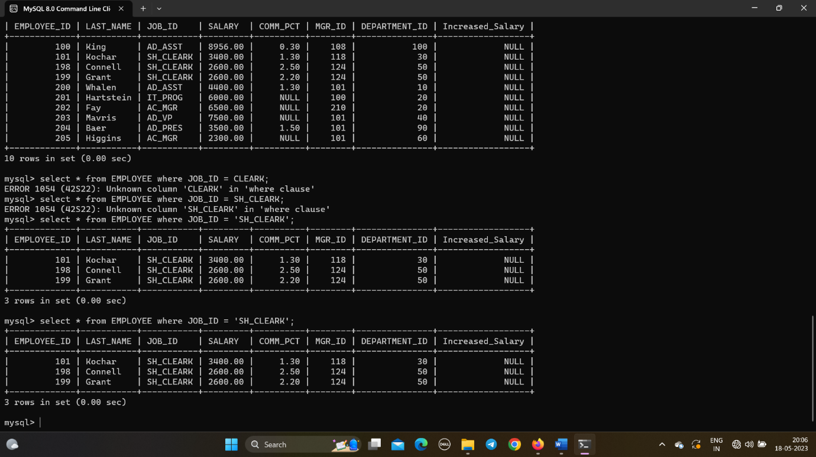

Q17. Update the job_id’s of the employees who earn more than 5000 to Grade_A.  
Display the table EMPLOYEE after updating.

* update EMPLOYEE set JOB_ID = 'GRADE_A' where SALARY>5000;
* 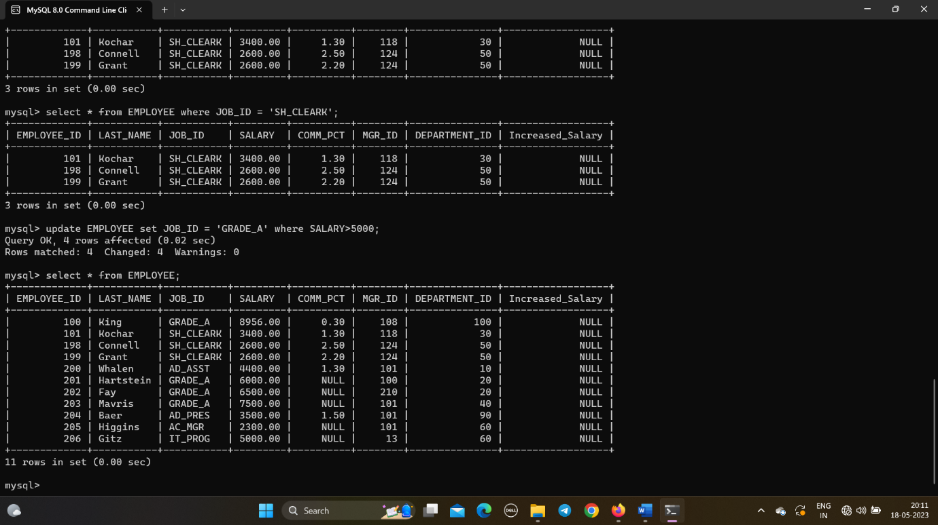

Q18 Display the details of all those employees who are either CLERK or  
PROGRAMMER or ASSISTANT.

* 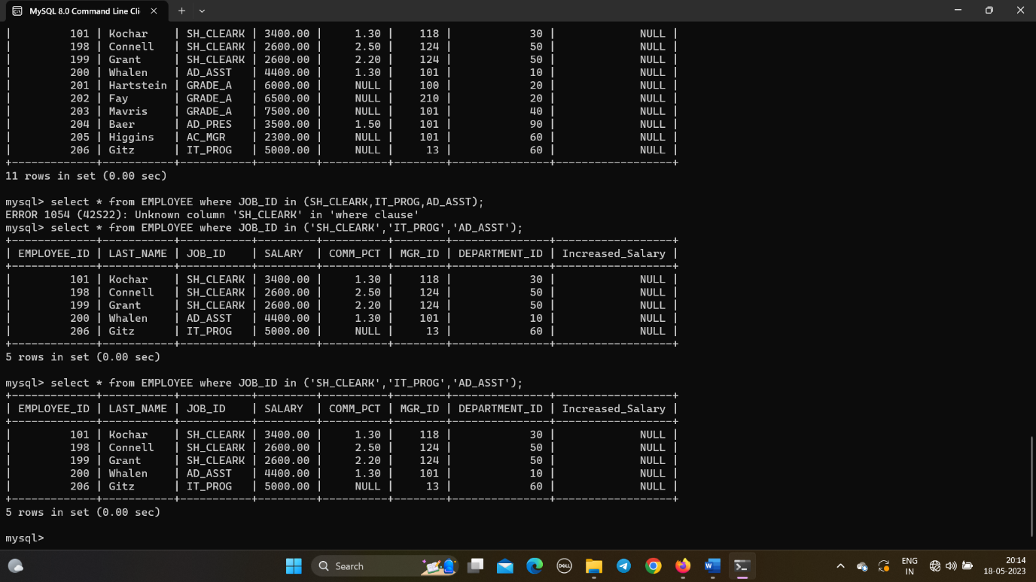select * from EMPLOYEE where JOB_ID in ('SH_CLEARK','IT_PROG','AD_ASST');

Q19 Display those employees from the EMPLOYEE table whose designation is  
CLERK and salary is less than 3000.

* select * from EMPLOYEE where JOB_ID = 'SH_CLEARK' and SALARY < 3000;
* 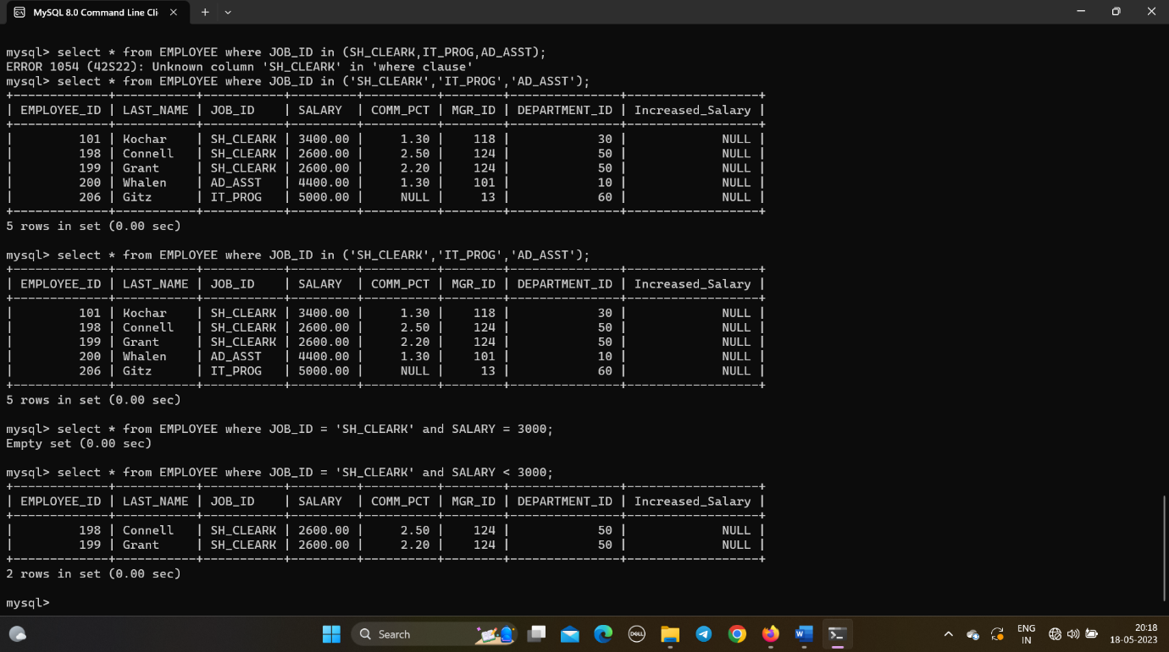

Q 20 Display those employees Last_Name, Mgr_id from the EMPLOYEE table whose  
salary is above 3000 and work under Manager 101.

* select LAST_NAME, MGR_ID from EMPLOYEE where SALARY > 3000 and MGR_ID = 101;
* 